**CARACTERISTIQUES GENERALES / *General Characteristics***

Robinet à papillon haute performance bidirectionnel double excentration. *Butterfly valve high performance double eccentric*

Conception standard *standard design* EN 12516

Test EN12266-1 Taux A ou ANSI/FCI 70-2 Class VI

Raccordement *end connection* ASME B16.5 – B16.47 / EN1092-1

F/F ISO 5752 serie 20 (EN558 serie 20), API609 Cat A et B

Conception unique de siège. *Unique seat design*

Siège lèvre de type Optimisé peut compenser automatiquement la température et les variations de pression, il a une capacité d'autorégulation, et sa performance d'étanchéité est sûr et fiable. / *Optimized type lip seat can automatically compensate for temperature and pressure variations, it has self-regulating ability, and its sealing performance is safe and reliable.*

Les utilisateurs peuvent remplacer le siège juste en prenant le bas du segment sur place, sans démontage de la plaque et de l'arbre valve, ce qui peut réduire les coûts de maintenance et de prolonger la durée de vie.

Bidirectionnelle sans bulles, zéro fuite étanchéité.  
*sers can replace the seat just by taking the bottom of the segment in place, without disassembling the plate and valve shaft, which can reduce maintenance costs and extend service life. Bidirectional bubble-free, zero leak tightness.*

**APPLICATION**

Usage général : Chimie, pétrochimie, raffineries, papeterie, hydrocarboné, énergie, industrie de l’acier.

/ General use: Chemicals, petrochemicals, refineries, paper industry, hydrocarbons, energy, steel industry.

Réducteur manuel / Poignée

Manual reducer / Handle

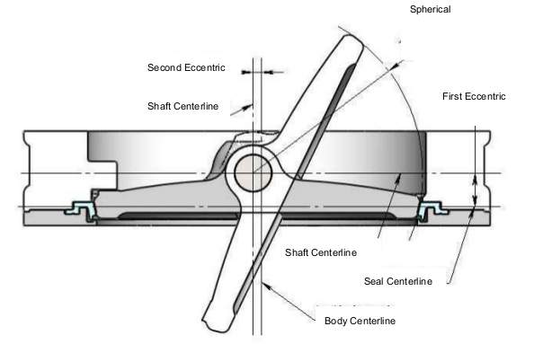

|  |  |  |
| --- | --- | --- |
| **Temperature** | **Mini** | **Maxi** |
| -29°C | + 210°C |

*(see material nomenclature)*

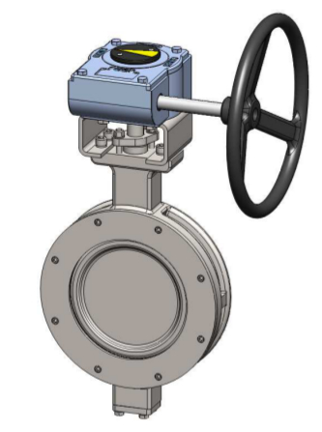



**ACTIONNEUR**

|  |  |  |
| --- | --- | --- |
| **Max Pressure** | **Construction** | |
| **25 bars** | **50 bars** |
| **DN** | DN50-750 | DN50-600 |
| **Raccordement**  **Connection** | Class150 | Class300 |
| PN20 / PN25 | PN50 |
| **Type** | Wafer / Lug | Wafer / Lug |

**NOMENCLATURE**

|  |  |
| --- | --- |
| **End type** | **Product code** |
| Wafer | BV02W |
| Lug | BV02L |

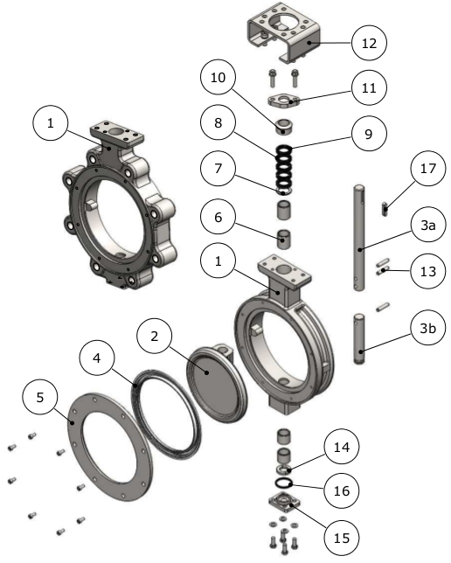

|  |  |  |  |
| --- | --- | --- | --- |
| **rep** | **Désignation** | **Materials configuration** | |
| **WCB** | **316** |
| **1** | CORPS / BODY | ASTM A216 WCB | ASTM A351 CF8M |
| **2** | PAPILLON / BUTTERFLY | ASTM A351 CF8 | ASTM A351 CF8M |
| **3a** | COMMAND AXIS | 17-4PH | 17-4PH |
| **3b** | STOP AXIS | 17-4PH | 17-4PH |
| **4** | SIEGE SEAT | See seat materials table | |
| **5** | CONTRE JOINT | ASTM A276 304 | ASTM A276 316 |
| **6** | PALIER / LANDING | ASTM A276 304/ | ASTM A276 316/ |
| ASTM A276 304+ENP | ASTM A276 316+ENP |
| **7** | BOTTOM WASHER PG | ASTM A276 304 | ASTM A276 316 |
| **8** | PACKING | See packing table materials | |
| **9** | PLAIT PACKING | See table of braided packing materials | |
| **10** | FOULOIR / GLAND | ASTM A276 304 | ASTM A276 316 |
| **11** | BRIDE PG | ASTM A216 WCB | ASTM A351 CF8M |
| **12** | ARCADE | A105 | ASTM A276 304 |
| **13** | GOUPILLE / PIN | 17-4PH | 17-4PH |
| **14** | BAGUE / RING | ASTM A276 304 | ASTM A276 316 |
| **15** | COUVERCLE / LID | ASTM A216 WCB | ASTM A351 CF8M |
| **16** | SEAL COVER | Flexible Graphite | Flexible Graphite |
| **17** | KEY | ASTM A276 420 | |
| **18** | SCREW, STUD | ASTM A193 B7/ASTM A193 B8/ASTM A193 B8M | |
| **19** | ECROU / NUT | ASTM A194 2H/ASTM A194 8/ASTM A194 8M | |

|  |  |
| --- | --- |
| **Matériaux optionnel / Optional materials** | |
| **Siège / Seat** | PTFE/RPTFE/ UHMWPE |
| **Garniture / Packing** | Flexible Graphite /PTFE/RPTFE |
| **Braided packing** | Braided Flexible Graphite /PTFE/RPTFE |

**DIMENSION ENCOMBREMENT / OVERALL DIMENSION**

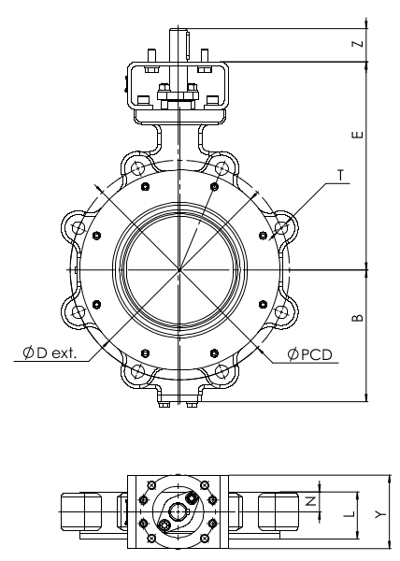

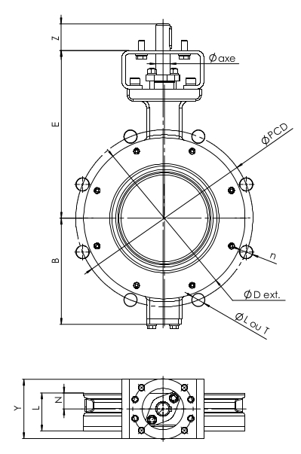

|  |  |  |  |  |  |  |  |  |  |  |  |
| --- | --- | --- | --- | --- | --- | --- | --- | --- | --- | --- | --- |
| **DN** | **B** | **E** | **L** | **N** | **Y** | **Z** | **ØD ext.** | **Ø Axe** | **Poids Wafer (kg)** | **Poids Lug (kg)** | **Iso Top** |
| **50** | 85 | 157 | 43 | 21,5 | * | 30 | * | * | 3,4 | 4,3 | F05 |
| **65** | 97 | 172 | 47 | 23,5 | * | 30 | * | * | 4,5 | 6,1 | F05 |
| **80** | 109 | 187 | 48 | 24 | * | 30 | * | * | 5,4 | 6,8 | F05 |
| **100** | 121 | 200 | 54 | 27 | * | 35 | * | * | 8,2 | 115 | F07 |
| **125** | 135 | 218 | 57 | 28,5 | * | 35 | * | * | 10,5 | 14,6 | F07 |
| **150** | 148 | 235 | 57 | 28,5 | * | 35 | * | * | 13 | 17 | F07 |
| **200** | 179 | 283 | 64 | 32 | * | 45 | * | * | 22 | 28,5 | F10 |
| **250** | 212 | 328 | 71 | 35,5 | * | 55 | * | * | 33,8 | 44,7 | F12 |
| **300** | 255 | 377 | 81 | 40,5 | * | 55 | * | * | 53,6 | 71,7 | F12 |
| **350** | 281 | 410 | 92 | 46 | * | 65 | * | * | 80 | 97 | F14 |
| **400** | 315 | 462 | 102 | 51 | * | 80 | * | * | 110 | 136 | F16 |
| **450** | 338 | 490 | 114 | 57 | * | 80 | * | * | 135 | 163 | F16 |
| **500** | 376 | 526 | 127 | 63,5 | * | 80 | * | * | 176 | 217 | F16 |
| **600** | 430 | 610 | 154 | 77 | * | 110 | * | * | 282 | 346 | F25 |
| **700** | 505 | 770 | 165 |  |  |  |  |  |  |  |  |
| **800** | 600 | 845 | 190 |  |  |  |  |  |  |  |  |
| **900** | 645 | 875 | 203 |  |  |  |  |  |  |  |  |
| **1000** | 700 | 975 | 216 |  |  |  |  |  |  |  |  |
| **1200** | 830 | 1170 | 254 |  |  |  |  |  |  |  |  |
|  | *on request | |  |  |  |  |  |  |  |  |  |

**DIMENSION RACCORDEMENT / CONNECTION DIMENTION**

|  |  |  |  |  |  |  |
| --- | --- | --- | --- | --- | --- | --- |
| **DN** | **ASME B16.5 Class 150 (ou ISO PN20)** | | | | | |
| **Ø PCD** | **nb trous n** | **WAFER** | | **LUG** | |
| **taraudés UNC (ou ISO)** | | **taraudés UNC (ou ISO)** | |
| **qté** | **T** | **qté** | **T** |
| **50** | 120,7 | 4 | - | - | 4 | 5/8" (ou M16) |
| **65** | 139,7 | 4 | - | - | 4 | 5/8" (ou M16) |
| **80** | 152,4 | 4 | - | - | 4 | 5/8" (ou M16) |
| **100** | 190,5 | 8 | - | - | 8 | 5/8" (ou M16) |
| **125** | 215,9 | 8 | - | - | 8 | 3/4" (ou M20) |
| **150** | 241,3 | 8 | - | - | 8 | 3/4" (ou M20) |
| **200** | 298,4 | 8 | - | - | 8 | 3/4" (ou M20) |
| **250** | 362 | 12 | - | - | 12 | 7/8" ou (M24) |
| **300** | 431,8 | 12 | - | - | 12 | 7/8" ou (M24) |
| **350** | 476,2 | 8 | 4 | 1" (ou M27) | 12 | 1" (ou M27) |
| **400** | 539,8 | 12 | 4 | 1" (ou M27) | 16 | 1" (ou M27) |
| **450** | 577,8 | 12 | 4 | 1"1/8 (ou M30) | 16 | 1"1/8 (ou M30) |
| **500** | 635 | 16 | 4 | 1"1/8 (ou M30) | 20 | 1"1/8 (ou M30) |
| **600** | 749,3 | 16 | 4 | 1"1/4 (ou M33) | 20 | 1"1/4 (ou M33) |

|  |  |  |  |  |  |  |
| --- | --- | --- | --- | --- | --- | --- |
| **DN** | **EN1092-1 PN25** | | | | | |
| **Ø PCD** | **nb trous n** | **WAFER** | | **LUG** | |
| **taraudés UNC (ou ISO)** | | **taraudés UNC (ou ISO)** | |
| **qté** | **T** | **qté** | **T** |
| **50** | 125 | 4 | - | - | 4 | M16 |
| **65** | 145 | 8 | - | - | 8 | M16 |
| **80** | 160 | 8 | - | - | 8 | M16 |
| **100** | 190 | 8 | - | - | 8 | M20 |
| **125** | 220 | 8 | - | - | 8 | M24 |
| **150** | 250 | 8 | - | - | 8 | M24 |
| **200** | 310 | 12 | - | - | 12 | M24 |
| **250** | 370 | 12 | - | - | 12 | M27 |
| **300** | 430 | 16 | - | - | 16 | M27 |
| **350** | 490 | 12 | 4 | M30 | 16 | M30 |
| **400** | 550 | 12 | 4 | M33 | 16 | M33 |
| **450** | 600 | 16 | 4 | M33 | 20 | M33 |
| **500** | 660 | 16 | 4 | M33 | 20 | M33 |
| **600** | 770 | 16 | 4 | M36 | 20 | M36 |



|  |  |  |  |  |  |  |  |  |  |  |
| --- | --- | --- | --- | --- | --- | --- | --- | --- | --- | --- |
| **DN** | **B** | **E** | **L** | **N** | **Y** | **Z** | **ØD ext.** | **Ø Axe** | **Poids Wafer (kg)** | **Poids Lug (kg)** |
| **50** | 85 | 157 | 43 | 21,5 | * | 30 | 98 | * | 3,4 | 5,3 |
| **65** | 97 | 172 | 47 | 23,5 | * | 30 | 117 | * | 4,5 | 7,4 |
| **80** | 109 | 187 | 48 | 24 | * | 30 | 128 | * | 5,4 | 9,3 |
| **100** | 121 | 200 | 54 | 27 | * | 35 | 167 | * | 8,2 | 13,8 |
| **125** | 146 | 231 | 59 | 29,5 | * | 35 | 190 | * | 13,4 | 18,2 |
| **150** | 170 | 260 | 59 | 29,5 | * | 35 | 216 | * | 17,2 | 25 |
| **200** | 189 | 298 | 73 | 36,5 | * | 45 | 272 | * | 27 | 34 |
| **250** | 237 | 355 | 83 | 41,5 | * | 55 | 332 | * | 51 | 71 |
| **300** | 275 | 395 | 92 | 46 | * | 65 | 400 | * | 78 | 107 |
| **350** | 306 | 435 | 117 | 58,5 | * | 80 | 442 | * | 116 | 180 |
| **400** | 340 | 487 | 133 | 66,5 | * | 80 | 504 | * | 158 | 236 |
| **450** | 375 | 525 | 149 | 74,5 | * | 80 | 540 | * | 215 | 327 |
| **500** | 405 | 565 | 159 | 79,5 | * | 110 | 597 | * | 265 | 426 |
| **600** | 480 | 660 | 181 | 90,5 | * | 110 | 708 | * | 423 | 654 |
|  | *on request | |  |  |  |  |  |  |  |  |

**DIMENSION RACCORDEMENT**

|  |  |  |  |  |  |  |
| --- | --- | --- | --- | --- | --- | --- |
| **DN** | **ASME B16.5 Class 300 (ou ISO PN50)** | | | | | |
| **Ø PCD** | **nb trous n** | **WAFER** | | **LUG** | |
| **taraudés UNC (ou ISO)** | | **taraudés UNC (ou ISO)** | |
| **qté** | **T** | **qté** | **T** |
| **50** | 127 | 4 | - | - | 4 | 5/8" (ou M16) |
| **65** | 149,2 | 4 | - | - | 4 | 3/4" (ou M20) |
| **80** | 168,3 | 8 | - | - | 8 | 3/4" (ou M20) |
| **100** | 200 | 8 | - | - | 8 | 3/4" (ou M20) |
| **125** | 235 | 12 | - | - | 12 | 3/4" (ou M20) |
| **150** | 269,9 | 12 | - | - | 12 | 3/4" (ou M20) |
| **200** | 330,2 | 12 | - | - | 12 | 7/8" ou (M24) |
| **250** | 387,4 | 12 | 4 | 1" (ou M27) | 16 | 1" (ou M27) |
| **300** | 450,8 | 12 | 4 | 1"1/8 (ou M30) | 16 | 1"1/8 (ou M30) |
| **350** | 514,4 | 16 | 4 | 1"1/8 (ou M30) | 20 | 1"1/8 (ou M30) |
| **400** | 571,5 | 16 | 4 | 1"1/4 (ou M33) | 20 | 1"1/4 (ou M33) |
| **450** | 628,6 | 20 | 4 | 1"1/4 (ou M33) | 24 | 1"1/4 (ou M33) |
| **500** | 685,8 | 20 | 4 | 1"1/4 (ou M33) | 24 | 1"1/4 (ou M33) |
| **600** | 812,8 | 20 | 4 | 1"1/2 (ou M39) | 24 | 1"1/2 (ou M39) |

|  |  |  |  |  |  |  |
| --- | --- | --- | --- | --- | --- | --- |
| **DN** | **EN 1092-1 PN40** | | | | | |
| **Ø PCD** | **nb trous n** | **WAFER** | | **LUG** | |
| **taraudés** | | **taraudés** | |
| **qté** | **T** | **qté** | **T** |
| **50** | 125 | 4 | - | - | 4 | M16 |
| **65** | 145 | 8 | - | - | 8 | M16 |
| **80** | 160 | 8 | - | - | 8 | M16 |
| **100** | 190 | 8 | - | - | 8 | M20 |
| **125** | 220 | 8 | - | - | 8 | M24 |
| **150** | 250 | 8 | - | - | 8 | M24 |
| **200** | 320 | 12 | - | - | 12 | M27 |
| **250** | 385 | 8 | 4 | M30 | 12 | M30 |
| **300** | 450 | 12 | 4 | M30 | 16 | M30 |
| **350** | 510 | 12 | 4 | M33 | 16 | M33 |
| **400** | 585 | 12 | 4 | M36 | 16 | M36 |
| **450** | 610 | 16 | 4 | M36 | 20 | M36 |
| **500** | 670 | 16 | 4 | M39 | 20 | M39 |
| **600** | 795 | 16 | 4 | M45 | 20 | M45 |